Annie Crockett

Mrs. Bridges

PRCM 3000

24 October 2023

**Lowcountry Public Relations Social Media Campaign**

Lowcountry Public Relations is a hospitality and tourism PR agency in Charleston, South Carolina. Our clients include restaurants, hotels, shops, and festivals. Our goal at LPR is to promote travel to Charleston through the wonderful hospitality options our clients offer. We want to share our brands' stories through social media. Specifically, through Instagram, influencer marketing, and sharing client testimonials and case studies.

**Steps of a social media campaign:**

1. Social media objectives.
2. Social media campaign audience analysis.
3. Social media campaign audit.
4. Industry social media analysis.
5. Social media content plan.
6. Test, evaluate, and adjust

**5 objectives for Lowcountry PR’s social media:**

1. Lowcountry Public Relations will feature weekly client highlights through Instagram reels. They will gain 5 followers each week by March 2024.
2. Lowcountry Public Relations will partner with 10 local and national influencers to reach a wider audience and promote travel to Charleston by posting bi-weekly on Instagram and TikTok with our clients. We will have the influencers hired by December of 2023 and they will feature restaurants, shops, and other things to do in the city.
3. Lowcountry Public Relations will share two success stories and case studies of clients on Instagram each month to showcase the company's ability to bring results and visitors to their clients in the city of Charleston. They will gain two new clients in Charleston by February 2024.
4. Lowcountry Public Relations will establish itself on TikTok by December of 2023. They will gain 1,000 followers by December 2024.
5. Lowcountry Public Relations will create a giveaway for a weekend stay with one of our hotels that will be shared on Instagram, TikTok, and Facebook. The giveaway will increase our following on all three platforms by January 2024.

**Audience Analysis:**

* *Demographics:* 
  + **Age:** Charleston attracts young adults, families, and older individuals wanting to retire. We also cater more to an older age demographic of 21 plus.
  + **Income:** There are various lodging, food, and activity options for all income levels. However, our clients are more middle/high-end travelers.
  + **Geographic Area:** Visitors come from the South, but also from all over the United States.
    - **Education:** Charleston’s attractions appeal to all education levels. Whether you are a history buff, into the arts, or just want to go to the beach, shop, and eat, Charleston is the perfect place for you!
    - **Gender:** The city attracts both males and females, but typically there are more women in Charleston for girls' trips than guys who travel alone.
* *Psychographics:*
  + **Beliefs:** The people who visit Charleston believe in experiences, quality time, exploration, relaxation, and fun.
  + **Values:** Those who visit the city value cultural experiences, exploring culinary traditions, outdoor experiences, beaches, family togetherness, and the arts.
  + **Attitudes:** The city attracts people who enjoy fine dining, the beach, heritage, history, hospitality, and warmth. The city is known for its southern hospitality, which draws people into the friendly atmosphere.
* *Lifestyle segments:*
  + **Beachgoers:** The city is surrounded by water and cute beach towns. There are beautiful beaches, water activities, and the opportunity to relax by the coast.
  + **Shopping fanatics:** Charleston has hundreds of stores up and down King Street, and all over the city. It is the perfect place for those who love to shop.
  + **History buffs:** Visitors who have a deep appreciation for history, culture, and heritage. There are plenty of historic sites, museums, and guided tours in the city.
  + **Food and drink enthusiasts:** Charleston is filled with fantastic five-star restaurants that people come to try from all over.
  + **Luxury travelers:** Travelers who seek upscale experiences can find many luxury hotels, spas, and boutiques in the city.
  + **Art fanatics:** The city is filled with beautiful art galleries that attract visitors from all over the United States.

**Industry Analysis:**

1. **Byrdhouse PR Charleston, South Carolina**
   1. Uses Instagram platform to highlight clients in the hospitality and tourism industry in Charleston, South Carolina.
   2. Highlights articles written about their client with creative social media posts on Instagram.
   3. Posts on Instagram a few times a week.
   4. Has reels scattered around on their social media content.
   5. Very fun and engaging content.
   6. High-quality content.
   7. 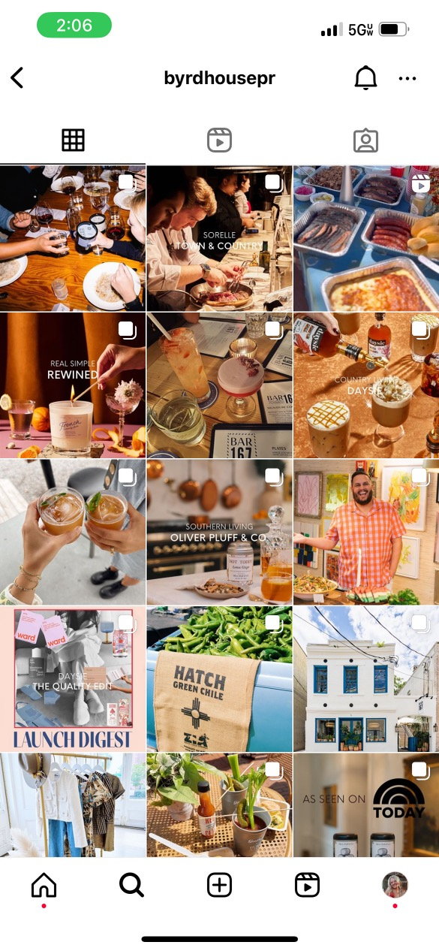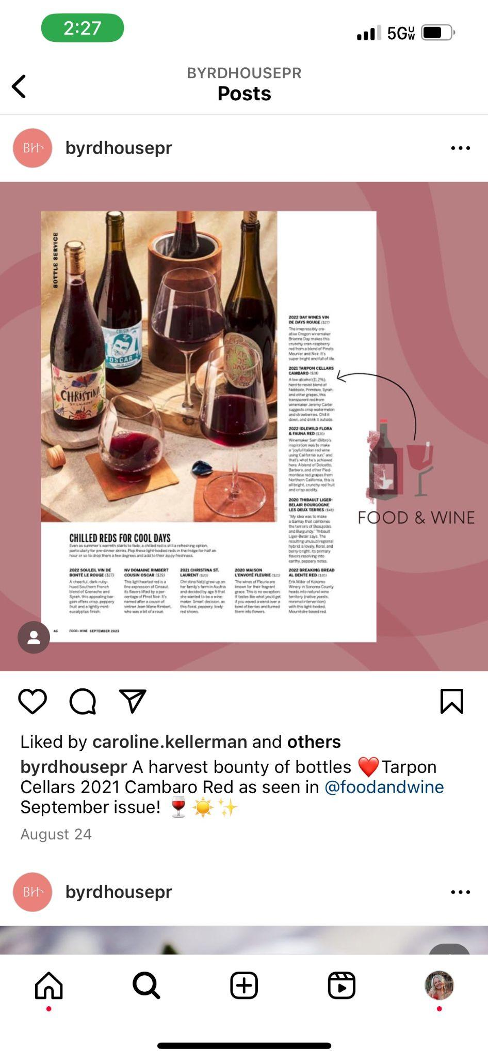
2. **Visit Savannah, Savannah, Georgia**
   1. Savannah is a competing city in Charleston, South Carolina. Visit Savannah does a great job at posting on their Instagram frequently.
   2. Visit Savannah partners with influencers and has a section on their highlights for their content.
   3. Has a large following of 166K and gets a lot of likes on every post.
   4. Uses Instagram stories to promote tagged photos, reels, and stories.
   5. 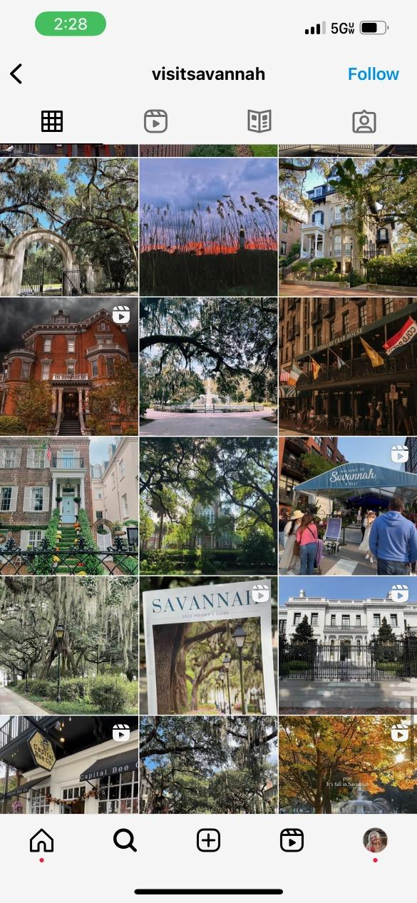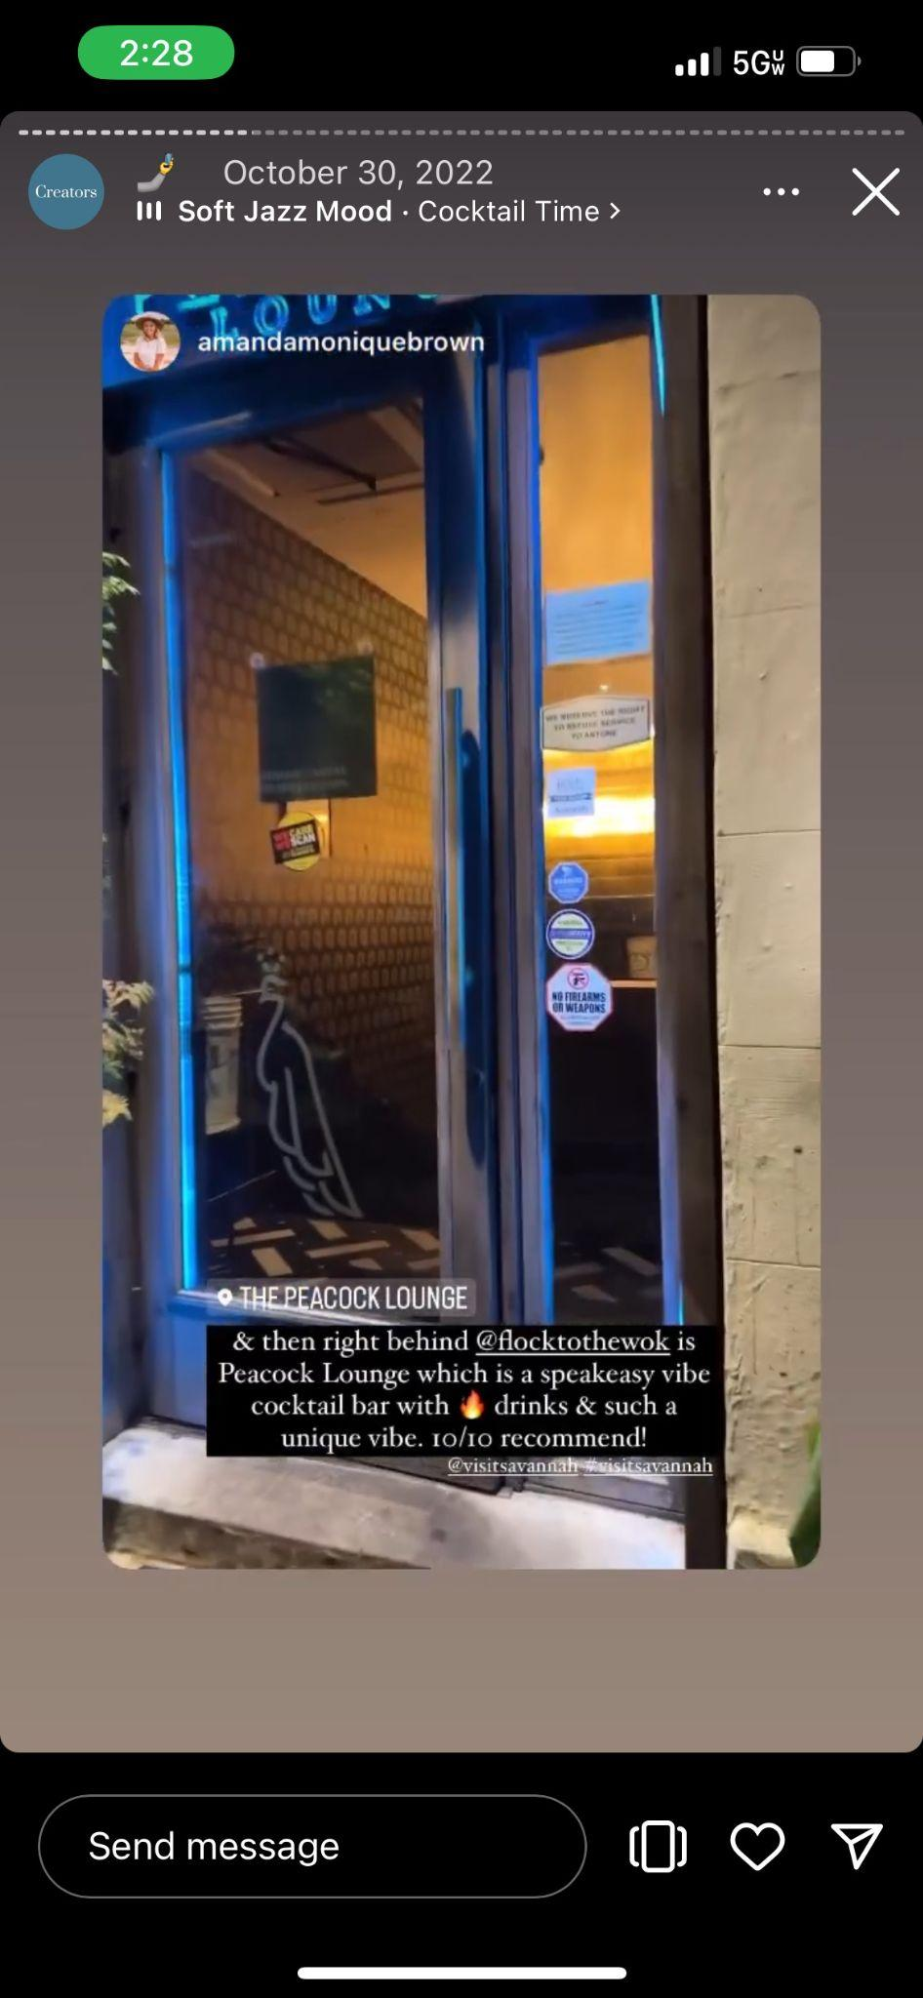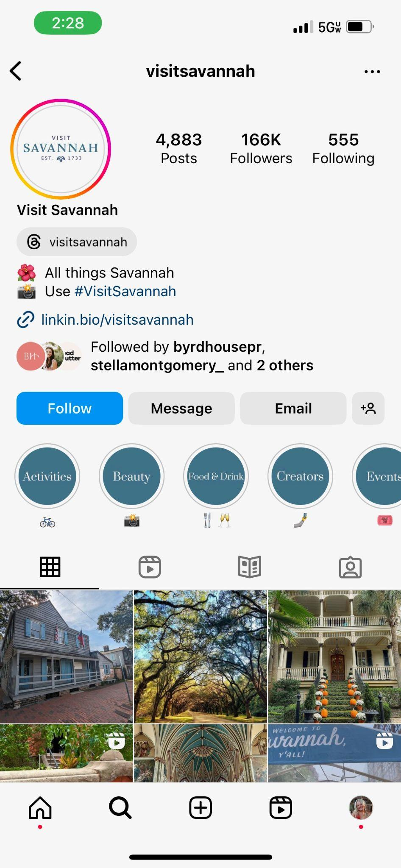
3. **Charlotte Berger PR, Charleston, South Carolina**
   1. Charlotte Berger PR is a competing agency in Charleston. They do a great job posting weekly client highlights of articles written.
   2. They also post shoutouts for their account managers and show that they are a collaborative agency.
   3. Use their platform on Instagram to promote clients' events around Charleston on stories and reels.
   4. 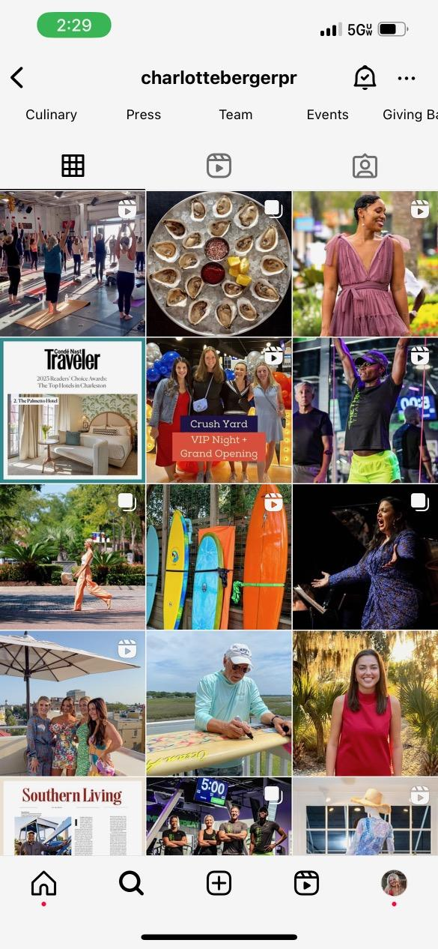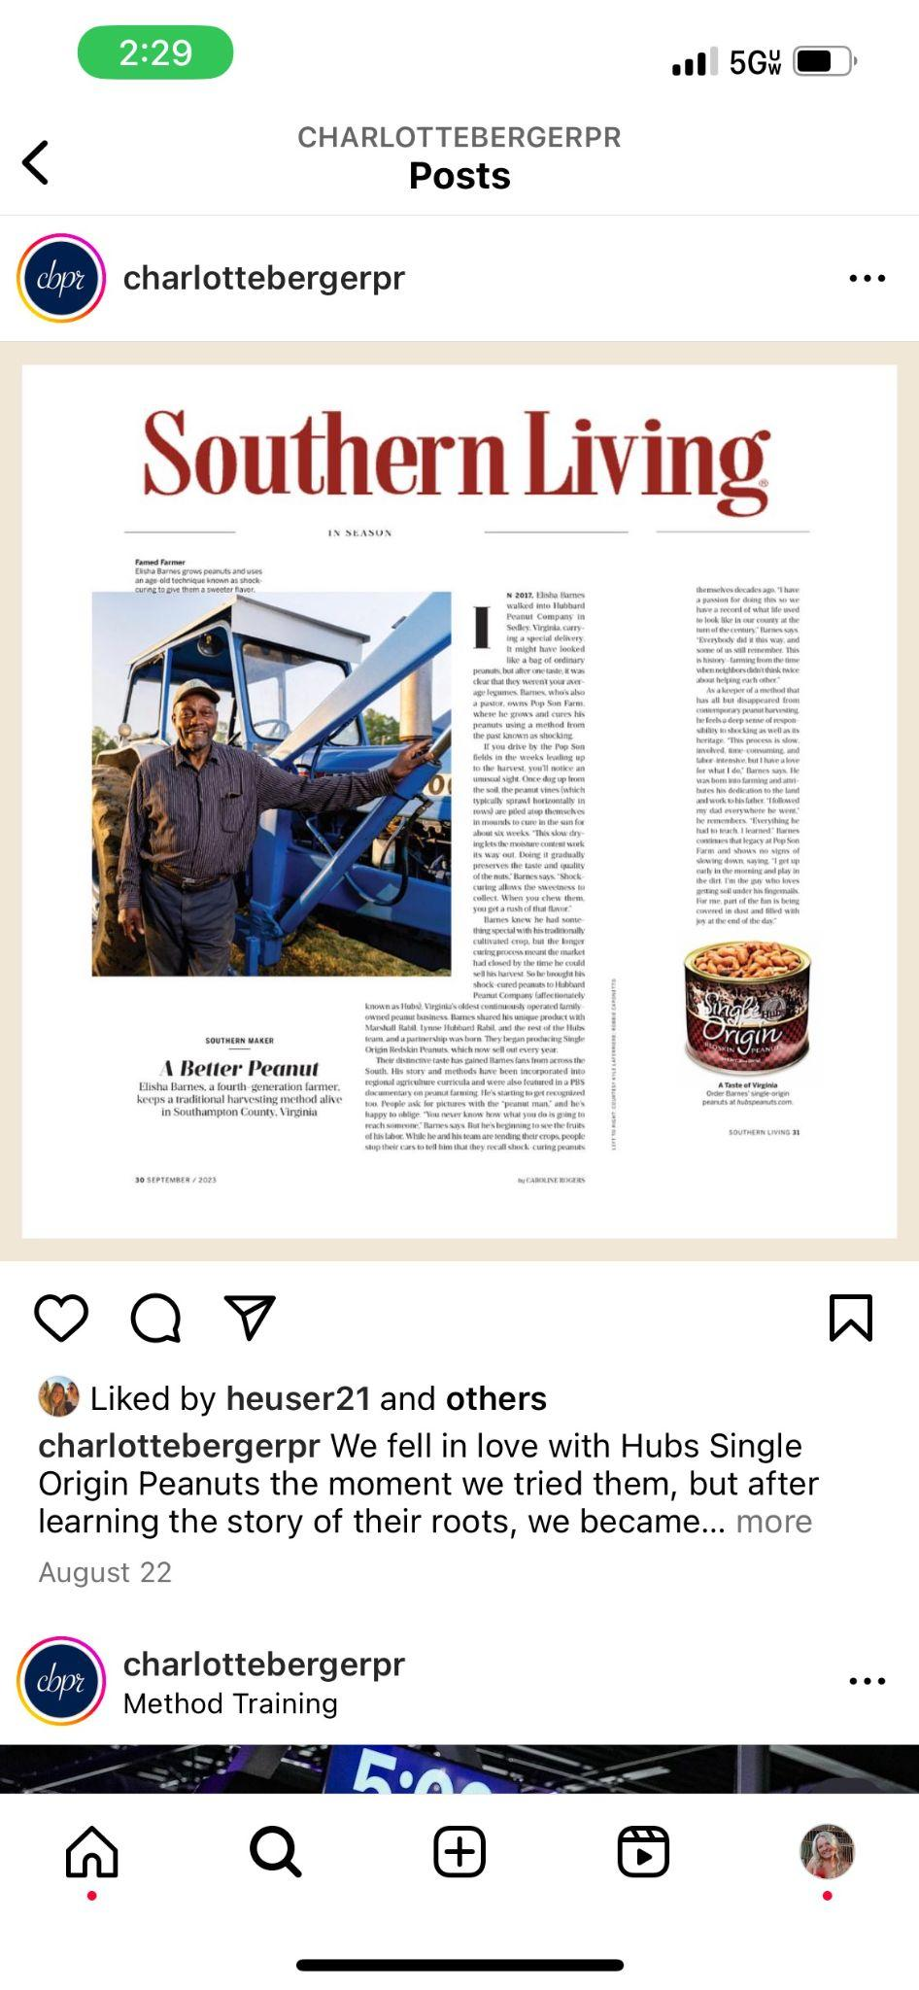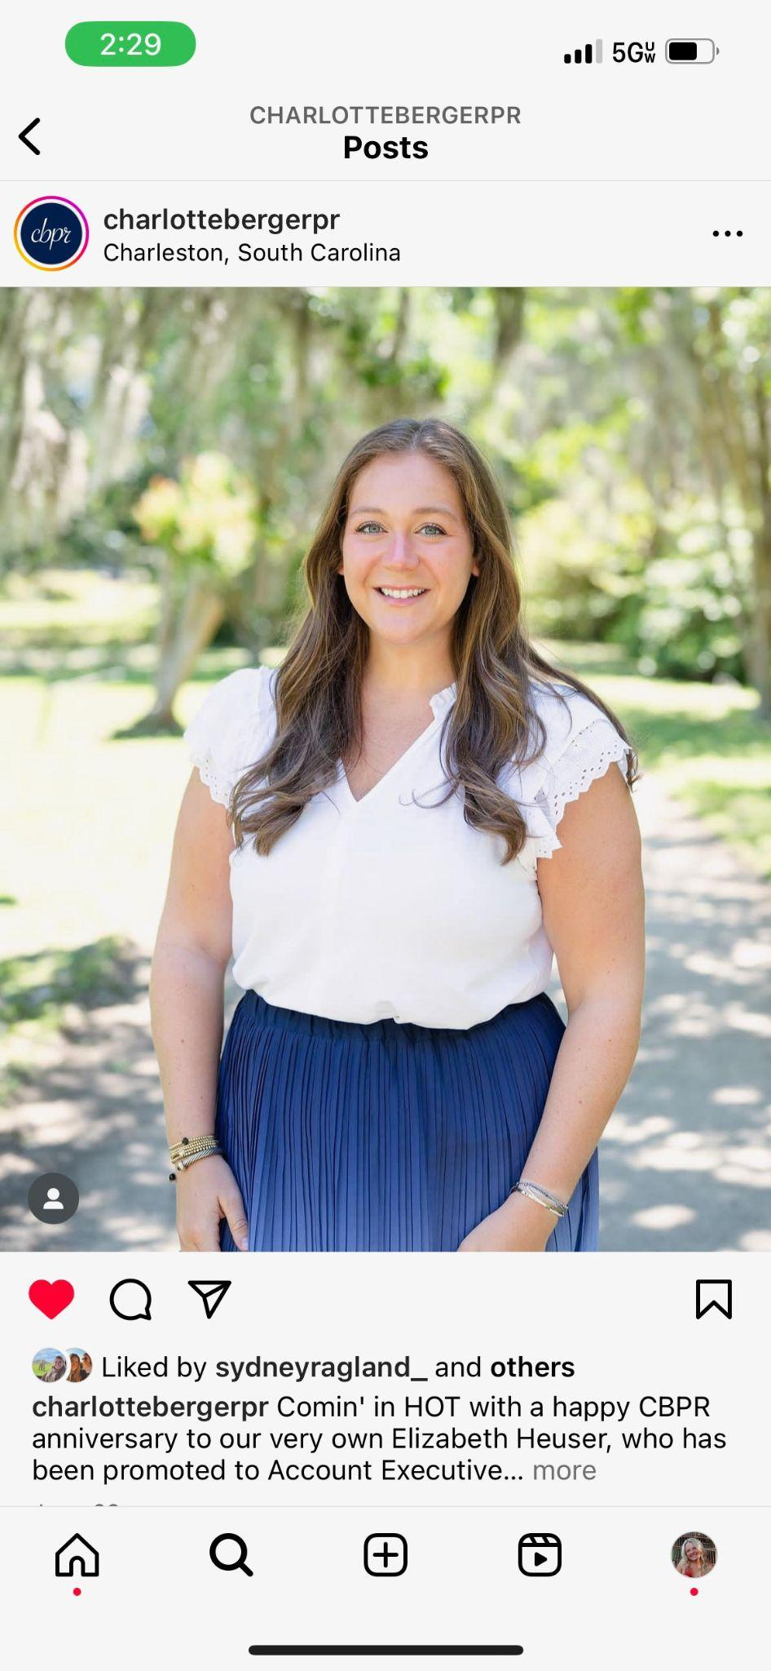
4. **bread & butter PR, location in Charleston, South Carolina**
   1. Posts client highlights weekly to showcase the results the agency brings in and the people they bring into the city.
   2. Has a strong following of 23.6K that brings people’s attention to the agency and has helped it gain new clients.
   3. Uses influencer marketing to promote their clients in Charleston, South Carolina shares their posts on their stories.
   4. 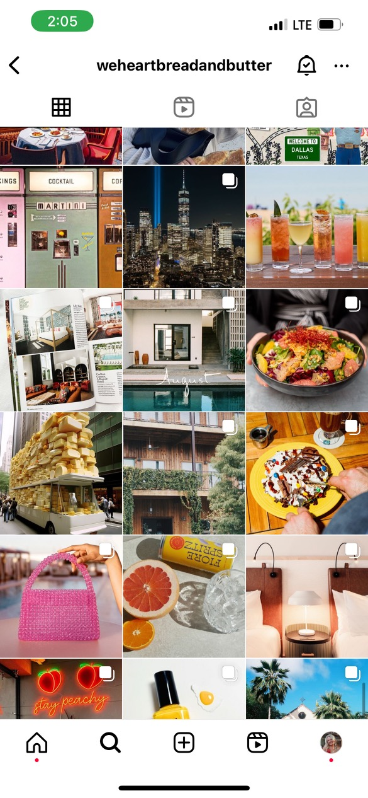 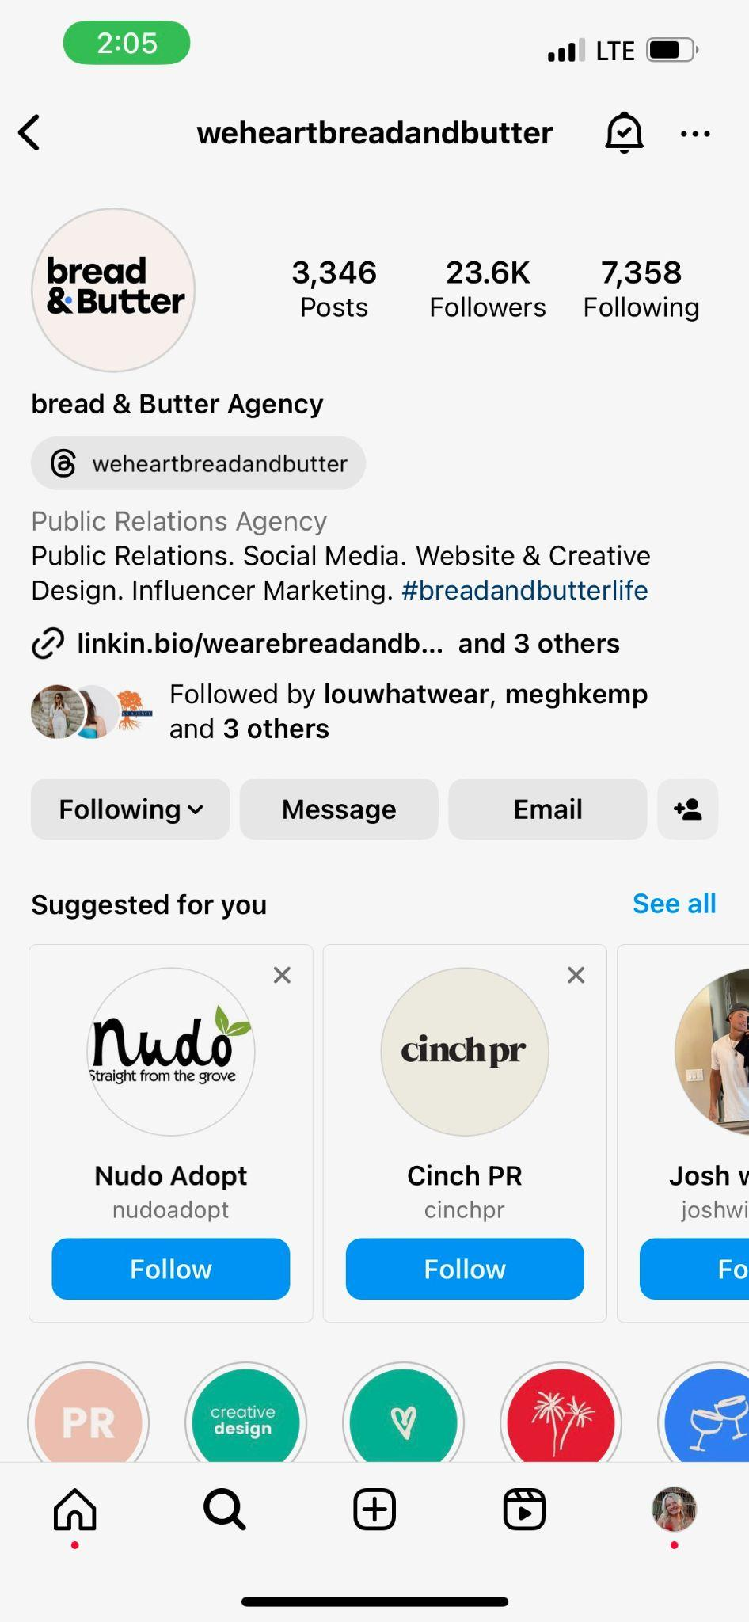
5. **Wilmington Coast, North Carolina** 
   1. Posts reel weekly about things to do around Wilmington, North Carolina.
   2. Has a strong following of 53.5K.
   3. Uses Instagram stories and influencers to cross-promote their content and their clients.
   4. 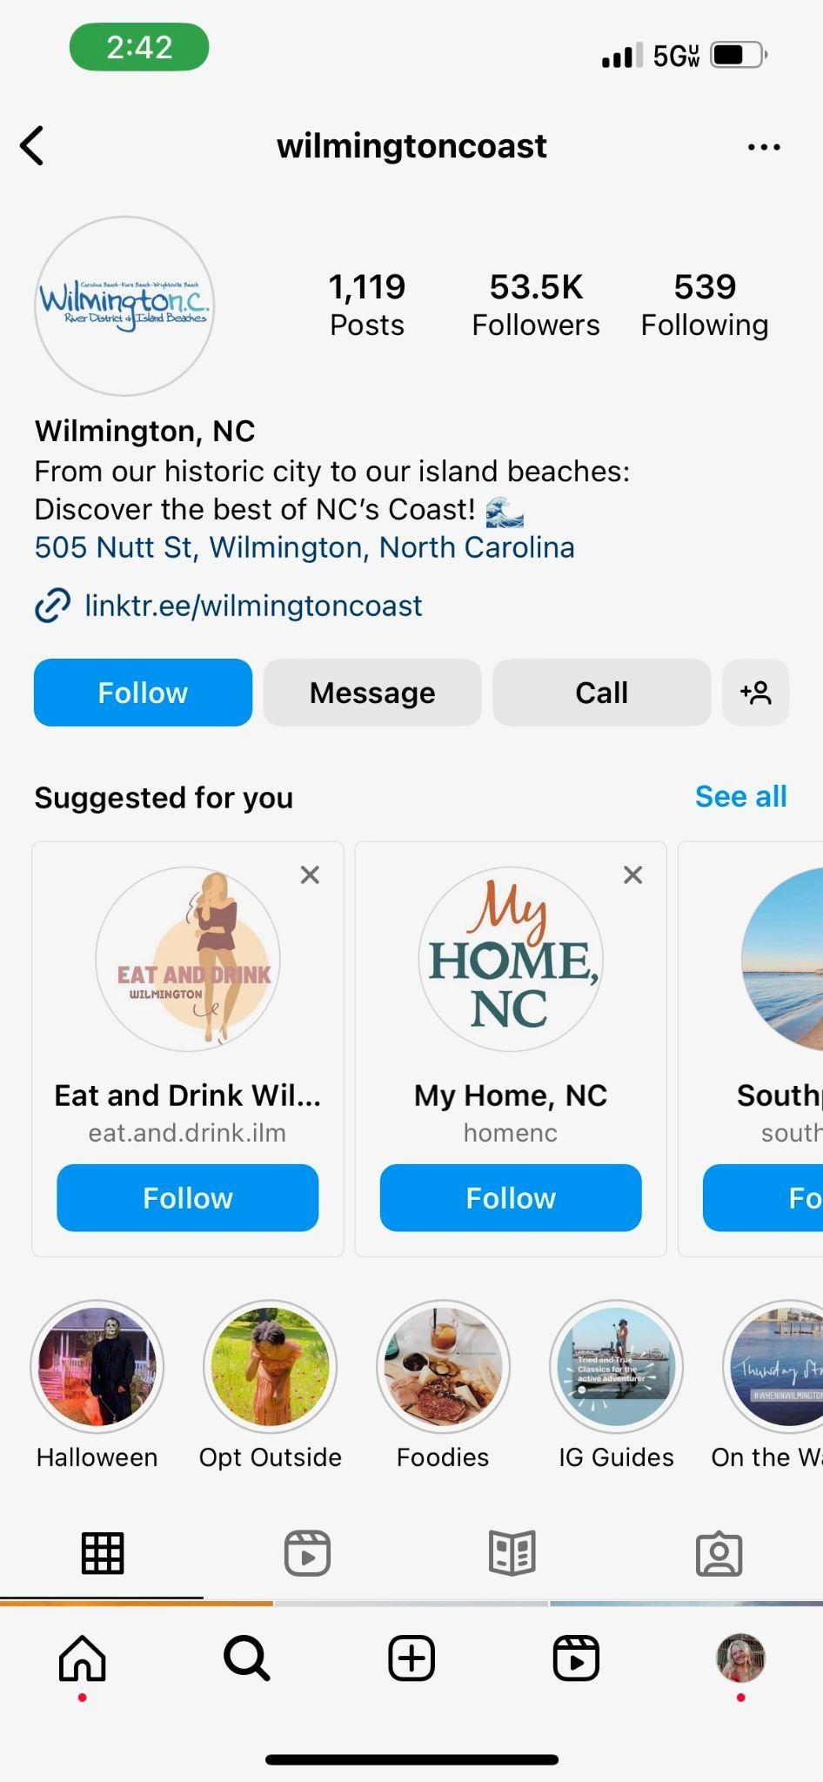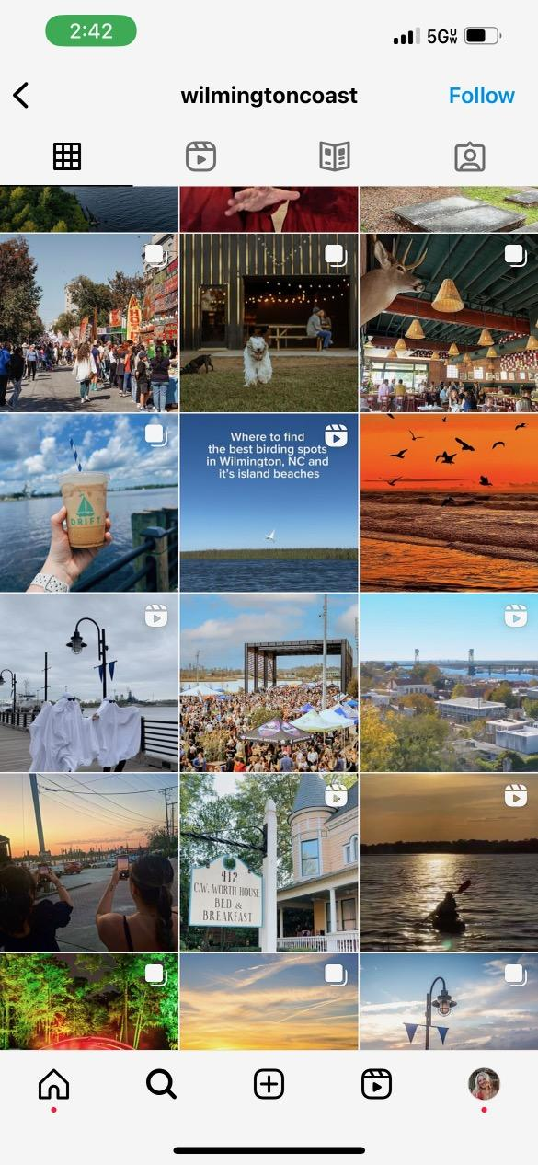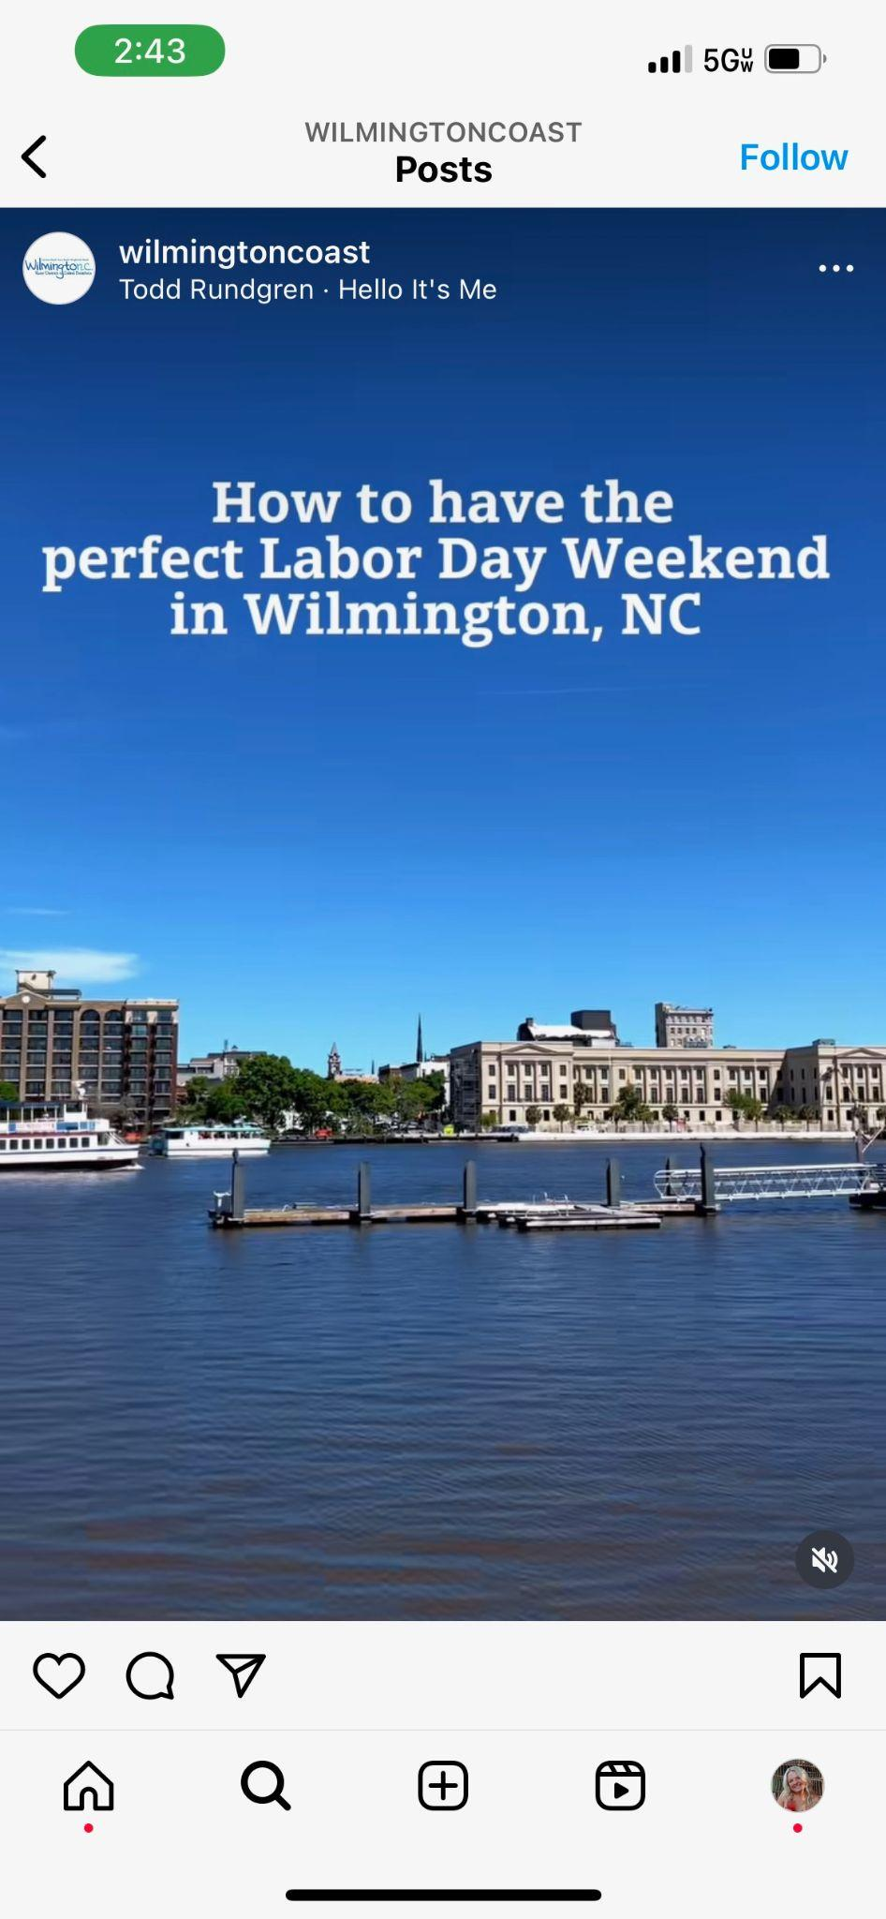

**Content Plan:**

* **Content Ratio:** I would like to post consistently three times a week. Consistency is important when posting because it keeps our information relevant. In these posts, I would include one reel and have the other two posts be static. We would also be active on our stories during content creation, openings, and client events.
* **Original Content:** The original content that will be covered on our platform of Instagram, Facebook, and TikTok will promote our clients. We will create reels to showcase our hotels, stores, and restaurants. This content will be created by our account managers and social media managers who will set up content creation days with our clients. We will also create stories to share in real time with our audience. We will use the stories to create a sense of community, engagement, and brand awareness. Finally, we will post content regularly to keep our audience engaged.
* **Curated Content:** Our curated content will come from our influencers who are hired to promote our clients. Except, there curated content will not be planned by us. These posts will likely come from stories that will be reposted on our platforms, as well as, on our client's platforms. They will also come from visitors to the city and those who are going to stay at our hotels, eat at our restaurants, or shop at our stores. This content will come from Instagram stories. This type of content will mostly be from visitors.
* **Feature Content:** Our feature content will come from articles and press releases written for our clients. Ideally, we would like to share one feature a week by highlighting them on our Instagram feed. These would be highlighted in a static post. Another form of feature content would be found on the news or in interviews if our client is having an event. We also will pitch press releases to various news outlets to share our content on each of our clients. We will also keep up with travel bloggers and any of the content they write about trips to Charleston. Those will be highlighted on our Instagram stories.
  + 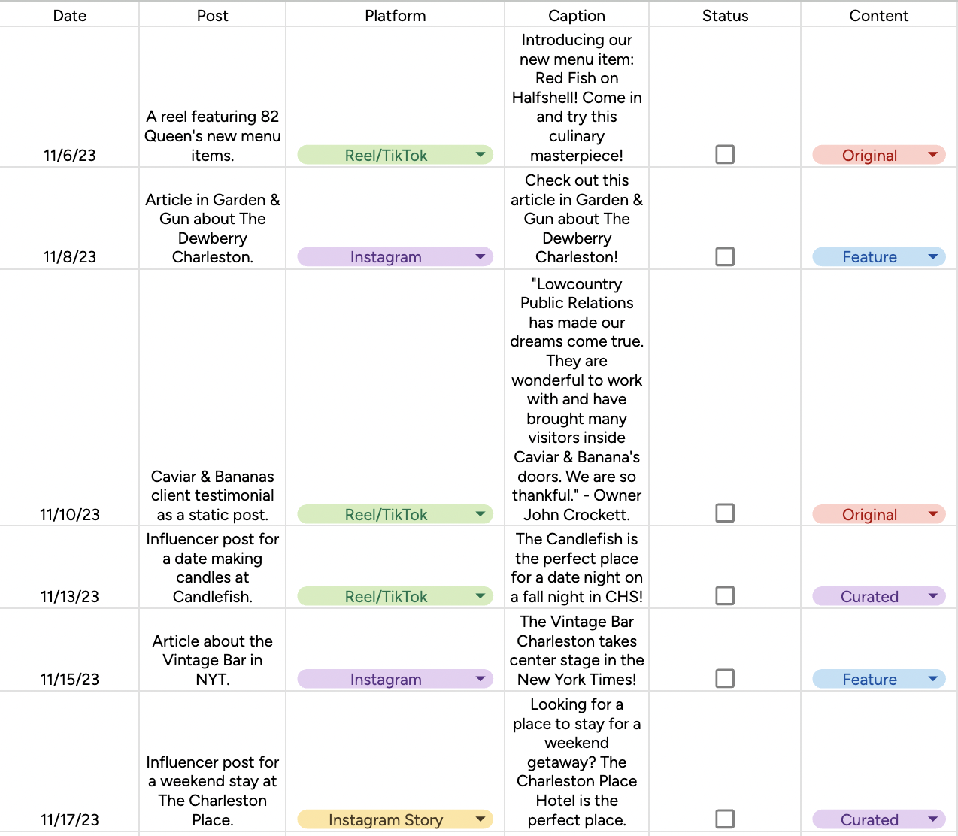
  + <https://docs.google.com/spreadsheets/d/1OyHDhxEwwpHYL_hHhETS8x55iCd3nlHH7j1Dsg4P4A4/edit#gid=0>